Annexe 2, Davidson House, 57 Queen Charlotte Street, Edinburgh, EH6 7EY

CHILD AND VULNERABLE ADULT PROTECTION (‘SAFEGUARDING’) POLICY

Earth in Common
4a Johns Place, Leith Links, Edinburgh EH6 7EL

Earth in Common is a registered Scottish Charity No. SC 044220

Contents
1. Introduction 2
2. Principles 2
3. Child and Vulnerable Adult Protection Code of Conduct 3
4. Child and Vulnerable Adult Protection Procedures 4
4.1 Definition of abuse 4
4.2. Definition of terms in Earth in Common’s Child and Vulnerable Adult Protection (‘Safeguarding’) Policy 5
5. Awareness-Raising 6
6. Prevention Measures 7
Staff and volunteer recruitment 7
EiC schools and children’s groups 8
Children and vulnerable adults working as volunteers 8
Communications and media 8
Earth in Common partners 9
7. Reporting 9
Earth in Common partners 10
8. Responding to Concerns 11
Earth in Common partners 12
Appendix 1: COMMUNICATION POLICY 13
1. Introduction 13
2. Use of images and stories 13
3. Consent 13
4. Confidentiality 14
5. Interviewing children and vulnerable adults 15
Earth in Common Child and Vulnerable Adult Protection Code of Conduct Agreement Form 16
Earth in Common Self-Disclosure Form 17
Earth in Common Child Volunteer Permission Form 19
Earth in Common Child Protection Concern Report Form 20
Body Map Guidance 23
Body Map 24
Consent Form for Use of Images of Children or Vulnerable Adults 28

Earth in Common
4a Johns Place, Leith Links, Edinburgh EH6 7EL

Earth in Common is a registered Scottish Charity No. SC 044220

Introduction

Children and vulnerable adults make up a significant proportion of people served by programmes supported by Earth in Common. Through outdoor and environmental education we improve, amongst other things, the lives of children and adults who suffer from poverty, inequality and other forms of disadvantage, and we recognise their particular vulnerability in these contexts. It is essential that everyone that we seek to support is protected from harm and benefits from our programmes in a safe, healthy and relaxed environment. We are committed to the rights of the child in the United Nations Convention on the Rights of the Child (UNCRC) and recognise our responsibility to ensure that those rights are upheld. We do not tolerate any violation or infringement of those rights and strive to ensure that the needs, dignity and safety of all children, regardless of gender, ethnicity, faith, ability or culture, are protected in our programme.

This Policy is for use by Earth in Common staff, trustees and volunteers in the UK and while on overseas visits. It is a guide for partners and a reference for potential partners, beneficiaries and the public. Its purpose is to provide protection from harm, primarily to children and vulnerable adults, and also to Earth in Common staff and volunteers and Earth in Common itself. It is guidance to realise our belief that all children, as defined in the UNCRC as anyone under the age of 18, even where defined otherwise in national contexts, and vulnerable adults, must be protected from abuse or exploitation. A vulnerable adult is afforded the same protection as a child. A vulnerable adult means a person aged 18 or over who has a condition of the following type:
- a learning or physical disability;
- a physical or mental illness, chronic or otherwise, including an addiction to alcohol or drugs;
- a reduction in physical or mental capacity;
- poverty; or
- low status, arising from prevailing social norms such as discrimination on grounds of sex or gender.

This policy is accompanied by procedures which are guided by the principles below. It is reviewed every year and the procedures and their implementation are monitored annually. A report on any incidents relating to child and vulnerable adults protection is made to the Board of Trustees annually. The Earth in Common Child and Vulnerable Adult Protection (‘Safeguarding’) Policy has been approved by the Earth in Common Board of Trustees. Concordance with the policy is mandatory for all Earth in Common staff, trustees and volunteers and for staff and volunteers of Earth in Common’s partner organisations, each of which must have and declare in writing that it implements a policy of similar or greater rigour, if Earth in Common is to work with it.

Principles

- All children and vulnerable adults have an equal right to development and their welfare is always promoted.
- Children and vulnerable adults are protected from any form of sexual, physical, verbal or emotional abuse or exploitation, from adults and other children.
- The health and safety of children and vulnerable adults is always paramount.
- Children and vulnerable adults are empowered to participate freely in decisions which affect their lives, recognising the importance of parents, families and other carers in their lives.
- Children and vulnerable adults are treated with respect, and valued as individuals and equals with respect to the context of their own culture, religion and ethnicity.
- Children and vulnerable adults are empowered to raise and discuss any concerns and are always listened to.
- Any allegation of abuse is treated seriously and dealt with appropriately and promptly. Victims and other involved parties are supported and perpetrators are held to account.
- Investigation of any Child and Vulnerable Adult Protection concern is conducted with reference to national laws and employment rights and immediately referred to relevant statutory authorities where appropriate.
- Staff and volunteers are recruited, supported and annually trained with respect to the Child and Vulnerable Adults Protection Policy.

Child and Vulnerable Adult Protection Code of Conduct

Earth in Common staff, trustees, volunteers, and staff and volunteers of Earth in Common’s partners must:
- Never hit or physically abuse a child or vulnerable adult in any way;
- Never deliberately place a child or vulnerable adult in danger or at risk of abuse;
- Never have sexual contact or use sexualised language with a child or vulnerable adult;
- Never develop personal relationships with a child or vulnerable adult which could lead to, or constitute, abuse;
- Never fondle, hold, kiss, hug or touch a child or vulnerable adult inappropriately;
- Never intentionally behave in a way that frightens or intimidates a child or vulnerable adult;
- Never purchase sex or otherwise condone prostitution while travelling for Earth in Common;
- Never do things of a personal nature for a child or vulnerable adult that they can do for themselves;
- Never single out a child or vulnerable adult for special treatment;
- Never give a child or vulnerable adult presents or personal items unless authorised by the Child and Vulnerable Adult Protection Officer;
- Never invite a child or vulnerable adult into their home or arrange to see them outside project activities unless authorised by the Child and Vulnerable Adult Protection Officer;
- Never stay alone overnight with a child or children or any vulnerable adult;
- Never take a child or vulnerable adult with them in their car, except in exceptional circumstances;
- Never hire a child or vulnerable adult for any service, or treat in any way which could be deemed exploitative;
- Never use internet resources such as social networking sites to make inappropriate contact with children or vulnerable adults which could lead to or constitute abuse;
- Never use racist, sexist, discriminatory, inappropriate, abusive or offensive language around children or vulnerable adults;
- Never intentionally humiliate or degrade children or vulnerable adults;
- Never smoke, use illegal drugs, consume or be under the influence of alcohol in the presence of children or vulnerable adults;
- Always treat children and vulnerable adults with respect;
- Always listen to children and vulnerable adults and their concerns;
- Always use sensitive language when a child or vulnerable adult reveals a serious issue (such as child abuse or sexual violence) (see section 7.3 for further details);
- Always endeavour to be accompanied by another adult when in the presence of children and vulnerable adults;
- Always deal with any allegations or concerns relating to abuse immediately and appropriately in accordance with the Child and Vulnerable Adult Protection Procedures;
- Always be aware of the health and safety of children and vulnerable adults and ensure that they are protected from harm when they are in our care;
- Always respect the rights of children and vulnerable adults and empower them to be aware of and act upon their rights;
- Always challenge the mistreatment of children and vulnerable adults and report any cases of abuse (items 7.1 to 7.11 cover the Reporting of any allegations; items 7.5, 7.6, and 7.7 cover the reporting to Child and Vulnerable Adult Protection Officer or manager);
- Always ensure that images of children and vulnerable adults are respectful and obtain permission from a child, vulnerable adult and/or their parent/guardian or carer before using their image. This applies to images taken in the UK or other countries.

Child and Vulnerable Adult Protection Procedures

4.1 Definition of abuse
The Scottish Government’s National Guidance for Child Protection in Scotland gives the following definitions:

Abuse and neglect are forms of maltreatment of a child. Somebody may abuse or neglect a child by inflicting, or by failing to act to prevent, significant harm on the child. Children may be abused in a family or in an institutional setting, by those known to them or, more rarely, by a stranger...The following definitions indicate how the abuse can be experienced by a child but are not exhaustive, as the individual circumstances of abuse will vary from child to child. The same principles apply in relation to the protection of vulnerable adults.

Physical Abuse | Physical abuse may involve hitting, shaking, throwing, poisoning, burning or scalding, drowning, suffocating, or otherwise causing physical harm to a child or vulnerable adult. Physical harm may also be caused when a parent or carer feigns the symptoms of, or deliberately causes, ill health to a child whom they are looking after. This situation may be described as fabricated or induced illness by the carer.
Emotional Abuse | Emotional abuse is where persistent emotional ill treatment of a child or vulnerable adult causes severe and persistent adverse effects on their emotional development. It may involve conveying to a child or vulnerable adult that they are worthless or unloved, inadequate or valued only in so far as they meet the needs of another person. It may feature age or developmentally inappropriate expectations being imposed on children or vulnerable adults. It may involve causing children or vulnerable adults to feel frightened or in danger, or the exploitation or corruption of children or vulnerable adults. Some level of emotional abuse is present in all types of ill treatment of a child or vulnerable adult, though it may occur independently of the other forms of abuse.
Sexual Abuse | Sexual abuse involves forcing or enticing a child or vulnerable adult to take part in sexual activities, whether or not they are aware of what is happening. The activities may involve physical contact, including penetrative or non-penetrative acts. They may include non-contact activities, such as involving children or vulnerable adults in looking at, or in the production of, pornographic material or in watching sexual activities, using sexual language towards a child or vulnerable adult or encouraging children or vulnerable adults to behave in sexually inappropriate ways.
Neglect | Neglect is the persistent failure to meet the basic physical and/or psychological needs of a child or vulnerable adult, likely to result in the serious impairment of their health or development. It may involve a parent or carer failing to provide adequate food, shelter and clothing, to protect a child or vulnerable adult from physical harm or danger, or to ensure access to appropriate medical care or treatment. It may also include neglect of, or unresponsiveness to, a child or vulnerable adult’s basic emotional needs. Neglect may also result in a child being diagnosed as suffering from non-organic failure to thrive, where a child has significantly failed to reach normal growth and developmental milestones and where physical and genetic reasons have been medically eliminated.

4.2. Definition of terms in Earth in Common’s Child and Vulnerable Adult Protection (‘Safeguarding’) Policy

Term | Definition | Example
UK staff | Earth in Common staff and trustees based in the UK. | Staff working in the Earth in Common office in Edinburgh.
UK contracted field office staff | Staff contracted in the UK working in an Earth in Common field office. | None at present and none foreseen.
Locally contracted field office staff | Staff contracted locally working in a Earth in Common field office. | None at present and none foreseen.
Volunteer | A volunteer who works for Earth in Common in the UK or another country. | A volunteer who helps in Earth in Common’s market garden or in the café/farm shop, or who helps us run events.
Earth in Common Manager | A member of staff who is responsible for managing other members of staff and/or an Earth in Common budget, in any country. | Chief Executive Officer or Croft Carbon College Project Officer.
Earth in Common Supervisor | A member of staff who is responsible for managing a designated volunteer, in any country. | Croft Carbon College staff who manage market garden volunteers. Nourishing Leith staff who manage café/farm shop volunteers.
Partners | Organisations/individuals which/who deliver projects, or elements of projects, and which receive funding from or work under the supervision of Earth in Common. | Organisations/individuals who deliver Croft Carbon College workshops for EiC. Organisations receiving funds from EiC for projects in Malawi (e.g. Living Trees of Livingstonia).
Partner staff and volunteers | The staff and volunteers of partners, whether in the UK or other countries. | Project coordinators who help deliver projects in Malawi or partner-delegated deliverers of workshops for the Croft Carbon College in Edinburgh.
Lead Child and Vulnerable Adult Protection Officer (Lead CVAPO) | A designated member of Earth in Common staff who has responsibility for child and vulnerable adult protection, both in the UK and other countries, as part of their role. The Lead CVAPO will monitor the charity’s work on child and vulnerable adult protection and provide guidance to the Child and Vulnerable Adult Protection Officers where necessary. | Earth in Common CEO
Child and Vulnerable Adult Protection Officers (CVAPOs) | Designated members of EiC staff who have responsibility for child and vulnerable adult protection issues as part of their role. | A member of EiC staff based outside the UK, though there are none at present and none are foreseen.
Safeguarding Committee | A group of EiC staff members and one board member who meet to review child and vulnerable adult protection issues twice a year. | Trustee, CEO, Project Officers

Awareness-Raising
5.1 Earth in Common’s Child and Vulnerable Adult Protection (‘Safeguarding’) Policy is freely available to all Earth in Common staff, trustees, volunteers, partners and partners’ clients. The Child and Vulnerable Adult Protection (‘Safeguarding’) Policy is available on the Earth in Common website and is regularly referenced in appropriate documents.

5.2 All new and existing Earth in Common staff are required to participate in annual training on Earth in Common Child and Vulnerable Adult Protection (‘Safeguarding’) Policy and are updated annually on child and vulnerable adult protection issues by the Safeguarding Committee, led by the Lead Child and Vulnerable Adult Protection Officer.

5.3 All new and existing volunteers in the UK and other countries, whose role involves contact with children and vulnerable adults are required to participate in training on Earth in Common’s Child and Vulnerable Adult Protection (‘Safeguarding’) Policy and are updated on the issues by their EiC staff supervisor.

5.4 All Earth in Common Managers are responsible for ensuring that their staff have participated in training on child and vulnerable adult protection and understand the Child and Vulnerable Adult Protection (‘Safeguarding’) Policy and its implications.

5.5 All new and existing Earth in Common staff in posts which have or may have regular contact with children and vulnerable adults, and the Child and Vulnerable Adult Protection Officers, are required to attend specialised training on child and vulnerable adult protection and may be required to attend further courses on this as necessary.

5.6 All new and existing staff, Trustees and volunteers are required to follow the Earth in Common Child and Vulnerable Adult Protection Code of Conduct and have signed a copy of this, which is kept on file. Refusing to sign may result in disciplinary action for staff and the termination of a relationship with volunteers.

5.7 Earth in Common engages with partners on child and vulnerable adult protection, explaining our commitments and requiring partners to have and declare in writing that they implement child and vulnerable adult protection policies and procedures which are relevant to their local context and compatible with the United Nations Convention on the Rights of the Child. Earth in Common encourages partners to use this policy as their model.

5.8 Earth in Common staff must always check against this policy when organising any Earth in Common event or visit.

Prevention Measures

Staff and volunteer recruitment
6.1 Earth in Common ensures that its employment and recruitment procedures and practices comply with local laws and refer to Keeping Children Safe standards and recommendations. In accordance with Scottish Government Getting It Right for every Child https://www2.gov.scot/Resource/0051/00514758.pdf

6.2 Recruitment of both internal and external candidates for posts which have or could have regular contact with children and vulnerable adults, including all posts involving travel outside the UK, must include:
- specifying that posts are disclosure-accepted posts for the Rehabilitation of Offenders Act 1974;
- making reference to Earth in Common’s commitment to child and vulnerable adult protection and the Child and Vulnerable Adult Protection (‘Safeguarding’) Policy in adverts and job descriptions;
- asking specific questions to candidates on their previous experience of working with children, young people or vulnerable adults;
- ensuring that candidates can provide two referees who can comment on their work with children, young people or vulnerable adults;
- ensuring that appointed candidates complete the appropriate disclosure process below;
- verifying the identity of candidates appointed to posts which will have or may have regular contact with children or vulnerable adults.

6.3 Job offers for posts which have regular contact with children and vulnerable adults, including all posts involving travel outside the UK, are subject to a Disclosure Process which will include Self Disclosure through the application process and, where required, Enhanced Disclosure, or the relevant local checks through the relevant national government agencies where possible. Satisfactory verification of qualifications and work history are also required.

6.4 Any volunteers who are recruited or designated for work with children and vulnerable adults are asked to complete a Self Disclosure form, provide two suitable referees and, where appropriate, complete an Enhanced Disclosure, or the relevant local checks through the relevant national government agencies where possible.

6.5 Any new or existing staff or volunteers who are unwilling to complete the Disclosure Process are not deployed in any position that allows them access to children or vulnerable adults.

EiC schools and children’s groups
6.6 Earth in Common staff and volunteers always endeavour to ensure that another responsible adult or teacher is present when working with children. Earth in Common staff and volunteers always attempt to minimise the likelihood of situations occurring in which they are lone adults working with one or more children.

6.7 Earth in Common partners who are involved in meetings with children during visits to the UK are always briefed on Earth in Common Child and Vulnerable Adult Protection (‘Safeguarding’) Policy, and are asked to sign the Child Protection Code of Conduct. A member of Earth in Common staff or a volunteer is present in any work involving children or vulnerable adults.

Children and vulnerable adults working as volunteers
6.8 All children and vulnerable adults are supervised by their legal guardian or by a responsible adult nominated by their legal guardian whilst undertaking voluntary work for Earth in Common. Adults do not supervise more than six children each.

6.9 Earth in Common staff or volunteers working with groups of children, such as school or scout groups who are volunteering for Earth in Common, ensure that school or relevant group leaders have obtained the necessary permission from parents or guardians. Responsibility for these children remains with the school or group.

6.10 Earth in Common supervisors ensure that children who are volunteering as individuals have provided a completed Child Volunteer Permission Form. A new form is completed on every occasion, unless the volunteer works with Earth in Common more than once a month, in which case the Form is kept on file and renewed on an annual basis.

Communications and media
6.11 Earth in Common ensures that the welfare of children and vulnerable adults is paramount and that their interests and safety always take priority over any editorial requirement.

6.12 The impact and possible consequences of any material which involves a child or vulnerable adult is carefully considered, both before and after publication or broadcast. The risks that children and vulnerable adults may face through their involvement in Earth in Common communications are continuously monitored and staff consider these on a case by case basis.

6.13 Earth in Common endeavours to ensure that images and/or stories about children and vulnerable adults cannot be misused or exploited.

6.14 Communications about children and vulnerable adults always respect the individual’s dignity and identity, and are not degrading. Earth in Common always endeavours to ensure that children and vulnerable adults are portrayed as realistically as possible and that language that implies any relationship of power is avoided.

6.15 Any material featuring in Earth in Common publications and website must be suitable for a general audience, including children. 6.16 Earth in Common staff and volunteers, whether in the UK or other countries, always:
- seek the consent of parents or legal guardians, or other person in loco parentis (e.g. teacher or group leader), and of the vulnerable adult themselves, before interviewing children and vulnerable adults, or taking film, photograph or sound recordings in which they appear; where practical, permission should be in writing;
- seek the consent of parents, legal guardians or other person in loco parentis, or of the vulnerable adult, before publishing any material in which a child or vulnerable adult appears;
- seek the consent of a child or vulnerable adult for their participation, and respect any refusal to take part;
- give no money to a child, vulnerable adult, parent or guardian to gain consent;
- obtain permission from the headteacher for any filming or interviewing on school premises during school hours;
- approach the gathering of material sensitively and consider the impact that recounting experiences may have on a child or vulnerable adult;
- take steps to minimise any distress that may be caused by taking part in an interview;
- provide extra protection to certain children and vulnerable adults who need it (for example, political refugees or those suffering from diseases);
- conceal the identity and location of children and vulnerable adults (for example withholding or changing names) when revealing their identity may lead to risk or distress;
- take additional steps to establish any potential risks where it is not possible to obtain individual permissions (for example in large group shots taken from a distance) and conceal the identity and location of children and vulnerable adults to mitigate any risks;
- endeavour to use images in which children and adults are adequately clothed, by the commonly accepted standards of UK viewers;
- consider the messages that are being communicated about children and vulnerable adults and ensure that these are fair and avoid stereotype or discrimination.

6.17 Where there is any doubt on the use of images and/or stories, Earth in Common staff and volunteers seek the guidance of their Child and Vulnerable Adult Protection Officer.

Earth in Common partners
6.18 Earth in Common Project Agreements specify that all partners must have child and vulnerable adult protection measures in place and should have and implement their own child and vulnerable protection policy. Partners must agree to abide by the Earth in Common Policy and Child and Vulnerable Adult Protection Code of Conduct.

Reporting

7.1 Earth in Common staff and volunteers have a duty to ensure that the Earth in Common Child and Vulnerable Adult Protection Code of Conduct is adhered to throughout the organisation.

7.2 A Child Protection Concern Report Form is freely available to all Earth in Common staff and volunteers.

7.3 Earth in Common staff and volunteers should respond sensitively to any Child Protection issue that they witness or is disclosed to them and treat the issue confidentially. If a child or vulnerable adult discloses that he or she is being abused, Earth in Common staff and volunteers should:
- stay calm,
- listen carefully and take the allegation seriously,
- not promise to keep it secret but explain that they need to tell someone else,
- stress that the individual was right to tell them, that they have taken it seriously and that they have understood what they have been told,
- only ask questions for clarity and not ask for explicit details,
- reassure the individual that they will take steps to help them and tell them what will happen next.

7.4 Earth in Common staff and volunteers should be confident that the disclosure of any serious allegation will not affect their position or reputation within Earth in Common.

7.5 Any Earth in Common staff member who witnesses or is informed of any potential breach of the Child Protection Code of Conduct must complete the Child Protection Concern Report Form and inform their line manager, other available senior member of staff or a Child and Vulnerable Adult Protection Officer of the concern immediately.

7.6 Any volunteer who witnesses or is informed of any potential breach of the Child Protection Code of Conduct must complete the Child Protection Concern Report Form and inform their designated Earth in Common supervisor of the concern immediately.

7.7 Earth in Common managers, supervisors or volunteer coordinator must inform the Child and Vulnerable Adult Protection Officer of any allegation or concern immediately. If for any reason this is not possible, staff must ensure that the matter is referred to an appropriate senior member of staff so that the concern can be managed with the necessary urgency.

7.8 The Child and Vulnerable Adult Protection Officer is responsible for the management of the investigation of any concern. Staff and volunteers should not seek to conduct their own investigation or discuss the issue with any other party such as other staff or volunteers.

7.9 The Child and Vulnerable Adult Protection Officer is responsible for ensuring that all records of any breach of the code of conduct are full and detailed, treated confidentially and stored securely.

Earth in Common partners
7.10 Partners must inform Earth in Common of any child and vulnerable adult protection concerns that occur within Earth in Common-funded projects or within their organisation immediately.

7.11 Any child and vulnerable adult protection concern relating to partners which is raised by staff, volunteers or members of the public must be properly recorded and raised with the relevant Child and Vulnerable Adult Protection Officer, senior staff and Chief Executive who will manage any response to this.
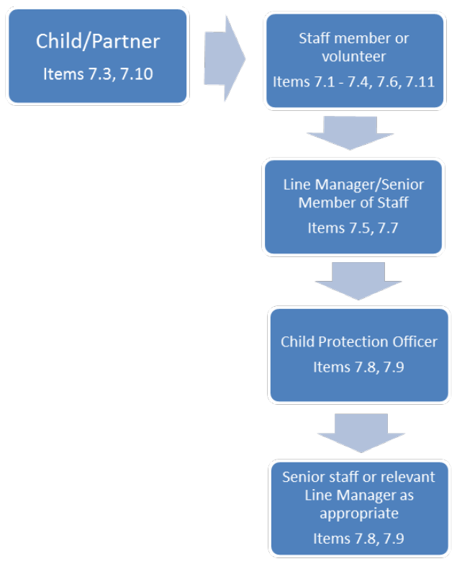

Responding to Concerns

8.1 The Child and Vulnerable Adult Protection Officer is responsible for ensuring that a thorough investigation of any concern is conducted, either by the CVAPO or by an appropriate member of staff, immediately, where there has been a breach of the Child and Vulnerable Adult Protection Code of Conduct by a member of staff or a volunteer. The Child and Vulnerable Adult Protection Officer should always refer any reported concern to the Chief Executive who may decide to report this to the Board of Trustees.

8.2 In some instances it may also be necessary for the Child and Vulnerable Adult Protection Officer to ensure that the concern is immediately referred to the relevant statutory authorities (i.e. Police or Child Welfare Authority) to ensure that the child or vulnerable adult is protected from any further harm, or to report a crime. In these instances the Child and Vulnerable Adult Protection Officer should always refer any reported concern to the Chief Executive who will report this immediately to the Board of Trustees.

8.3 It may be necessary for a member of staff to be suspended whilst an investigation is taking place. Any suspension will be as brief as possible and on full pay. Any action taken will be in line with the Earth in Common Disciplinary, Appeal and Grievance Procedure.

8.4 It may be necessary for a volunteer to be suspended whilst an investigation is taking place. Any suspension will be as brief as possible.

8.5 Earth in Common will endeavour to ensure that any child, vulnerable adult or other party who has been affected by any breach of the code of conduct is given immediate and appropriate support and care and that steps are taken to ensure that the child or vulnerable adult will receive appropriate long-term support where necessary.

8.6 Earth in Common will endeavour to ensure that any member of Earth in Common staff or volunteer who has been suspended whilst an investigation is taking place is given appropriate support. Suspension during an investigation does not constitute disciplinary action or imply guilt and if no breach has taken place, records of any investigation will be destroyed with one year of the investigation.

8.7 The Child and Vulnerable Adult Protection Officer is responsible for ensuring that a full investigation report is produced, which will be reviewed by the appropriate line manager and senior staff members. Any investigation will always be conducted with reference to national laws and employment rights and where any concern could constitute a criminal act the details will be immediately referred to any relevant statutory authorities.

8.8 Following full investigation, Earth in Common may implement the relevant disciplinary action for staff in accordance with Earth in Common’s Disciplinary Procedure. Staff have the right to respond to this as appropriate, in accordance with the Earth in Common staff handbook.

8.9 Where a concern relates to any volunteer, Earth in Common may choose to end the volunteer relationship.

Earth in Common partners
8.10 Partners must report the outcome of any internal investigation regarding a Child and Vulnerable Adult Protection concern to Earth in Common immediately. Earth in Common expects Partners to ensure that appropriate actions are taken in relation to any concern and to report the action taken to Earth in Common. In cases where Earth in Common judges that sufficient actions have not been taken, Earth in Common may choose to end a partner relationship.

Additional Documents
- Code of Conduct Agreement Form
- Child and Vulnerable Adult Protection Self-Disclosure Form
- Child Volunteer Permission Form
- Child and Vulnerable Adult Protection Concern Report Form
- Photograph Consent Form

Appendix 1: COMMUNICATION POLICY

1. Introduction

We live in a world where images of children and vulnerable adults are very often exploited and we recognise that children are particularly vulnerable to trafficking and abuse. Earth in Common is committed to the protection of children and vulnerable adults as a fundamental principle. This is achieved through programme implementation, recruitment of employees and volunteers, and communications.

This document sets out Earth in Common’s policy and practice in the gathering and publication of images, video footage and text referring to children and vulnerable adults, and is one of a set of documents governing the Child and Vulnerable Adult Protection (‘Safeguarding’) Policy.

The practice described is intended to ensure that the rights of children and vulnerable adults are respected, while allowing Earth in Common to report on the work of its partners using stories and images, both still and moving.

2. Use of images and stories

- Earth in Common’s communications about children and vulnerable adults must respect the individual’s dignity and identity.

- We strive to:
  - Portray children and vulnerable adults as realistically as possible, in their own context, without being overly sensational or overly positive, and without portraying children and vulnerable adults as victims;
  - Represent different types of children and vulnerable adults in the areas where our partners work and take care to portray the perspectives of children and vulnerable adults;
  - Be aware that some children and vulnerable adults may need extra protection when their stories are told, for example, those who have been orphaned by AIDS or who are living with HIV/AIDS;
  - Ensure that children and vulnerable adults and their legal guardians are fully informed of any possible risks and made aware of their rights so that they can make informed decisions about sharing their story;
  - Ensure that participants see how their story is used in Earth in Common materials;
  - Empower children and vulnerable adults through telling their story.

3. Consent

Wherever possible, as well as gaining consent from the child or vulnerable adult, Earth in Common will acquire verbal or written consent from the parent, carer, child’s school, whoever is acting in loco parentis (e.g. the partner organisation responsible for the child or vulnerable adult) or the vulnerable adult themselves, to use images and stories for external communication. This may not always be possible when dealing with crowd shots.

No payment or reward shall be given to gain consent. There must be no payment to minors for information involving the welfare of children or vulnerable adults, or payment to parents, guardians or carers (including schools and partners) for information about children or wards.

It will be made clear to all, including children, vulnerable adults, parents (and those in loco parentis), carers, guardians and vulnerable adults, that receiving support from an Earth in Common partner does not oblige them to participate in our communications.

When photographing or filming in schools, it is good practice to give the school sufficient advance notice so that they can contact children’s parents to gain consent.

Even if informed consent has been received, Earth in Common may decide not to publish a story if it is regarded as damaging to the child’s interest.

4. Confidentiality

While it is extremely important to publish real stories and photographs for the sake of authenticity and transparency, Earth in Common shall strive to protect the identity of children and vulnerable adults on two fronts:
- To avoid the exploitation of images and stories by those who may wish to misuse them; and
- To protect children and vulnerable adults from being stigmatised or mistreated in their own communities as a result of any publication arising from the interview or subsequent publication of photographs or images.

For the above reasons, Earth in Common will not use the name or family name, or name of school of a child or vulnerable adult, in external communications and/or reports to donors.

Sensitive cases
Identities should be further protected where children and vulnerable adults have particularly sensitive stories to tell, like
- Sexual abuse
- Domestic violence
- Pending or current court cases
- Child labour
- Living with HIV/AIDS
- Fostered girls and boys
- Prostitution
- Other economic or political factors that might threaten the safety of a child or vulnerable adult.

Identities shall be protected by using a pseudonym, to protect a child’s or vulnerable adult’s identity, and be footnoted in the text with the following: ‘Names have been changed in order to protect the identities of those involved.’

Care should also be taken to make sure that the name change is noted for future use of the same story and photographs.

Exceptions
Exception to the above guidelines can be made when the audience for a particular communication is limited and is known by Earth in Common (e.g. a letter to major donors or funding report to a known funding agency).

Family names and school names could be used for the sake of transparency to illustrate nonsensitive stories in these circumstances.

5. Interviewing children and vulnerable adults

All interviews with children and vulnerable adults should be conducted with extra care for the welfare and safety of the individual. The cultural values, interests and priorities of the individual should be honoured, and child-friendly language should be used. Information should be shared with the interviewee in a transparent way.

Questions that are overly intrusive or sensationalised are not allowed.

Children and vulnerable adults should not be interrogated about private family matters nor asked expressions of opinion on matters likely to be beyond their judgement.

The Earth in Common Child and Vulnerable Adult Protection (‘Safeguarding’) Policy shall be adhered to at all times when interviewing and photographing or filming a child or vulnerable adult.

Earth in Common Child and Vulnerable Adult Protection Code of Conduct Agreement Form

I agree to abide by the following code of conduct and to:
- Never hit or physically abuse a child or vulnerable adult in any way;
- Never deliberately place a child or vulnerable adult in danger or at risk of abuse;
- Never have sexual contact or use sexualised language with a child or vulnerable adult;
- Never develop a personal relationship with a child or vulnerable adult which could lead to, or constitute, abuse;
- Never fondle, hold, kiss, hug or touch a child or vulnerable adult inappropriately;
- Never intentionally behave in a way that frightens or intimidates a child or vulnerable adult;
- Never purchase sex or otherwise condone prostitution while travelling for Earth in Common;
- Never do things of a personal nature for a child or vulnerable adult that they can do for themselves;
- Never single out a child or vulnerable adult for special treatment;
- Never give a child or vulnerable adult presents or personal items unless authorised by the Child and Vulnerable Adult Protection Officer;
- Never invite a child or vulnerable adult into my home or arrange to see them outside project activities unless authorsed by the Child and Vulnerable Adult Protection Officer;
- Never stay alone overnight with a child or children or any vulnerable adult;
- Never take a child or vulnerable adult with me in my car, except in exceptional circumstances;
- Never hire a child or vulnerable adult for any service or treat a child or vulnerable adult in any way which could be deemed exploitative;
- Never use internet resources such as social networking sites to make inappropriate contact with children or vulnerable adults which could lead to or constitute abuse;
- Never use racist, sexist, discriminatory, inappropriate, abusive or offensive language around children or vulnerable adults;
- Never intentionally humiliate or degrade children or vulnerable adults;
- Never use illegal drugs, consume or be under the influence of alcohol in the presence of a child or vulnerable adult;
- Always treat children and vulnerable adults with respect;
- Always listen to children and vulnerable adults and their concerns;
- Always use sensitive language when a child or vulnerable adult reveals a serious issue (such as abuse or sexual violence);
- Always endeavour to be accompanied by another adult when in the presence of a child, children, vulnerable adult or vulnerable adults;
- Always deal with any allegations or concerns relating to abuse immediately and appropriately, in accordance with the Child and Vulnerable Adult Protection Procedures;
- Always be aware of the health and safety of children and vulnerable adults and ensure that they are protected from harm when they are in the care of Earth in Common;
- Always respect the rights of children and vulnerable adults and empower them to be aware of and act upon their rights;
- Always challenge the mistreatment of children and vulnerable adults and report any cases of abuse;
- Always ensure that images of children and vulnerable adults are respectful, and obtain permission from a child, vulnerable adult and/or their parent/guardian or carer before using their image.

Name:______________________________________________
Signature:___________________________________________ | Date:______________

Earth in Common Self-Disclosure Form

Any member of Earth in Common staff or volunteer being recruited by Earth in Common whose work will involve contact with children and vulnerable adults is required to disclose all relevant charges and convictions.

If you are provisionally offered employment or voluntary opportunities for a post which will involve work with children and vulnerable adults, we may seek an Enhanced Disclosure from the relevant authority. This type of disclosure will include any non-conviction information considered relevant by the Chief Constable or the relevant authority.

Earth in Common is committed to equality, meaning we will be fair in our recruitment process. A conviction will not necessarily be a barrier to working with us and any information you provide will be treated in the strictest confidence.

Please complete the following information, which is aimed at helping us establish your suitability for this post and verifying the authenticity of your application:
Surname:
Forenames:
Previous Surnames:
Date of Birth:
Male/Female:
Position Applied For:
Please give your current address
Do you have any previous convictions, cautions, reprimands or final warnings? |  | Yes/No
If Yes, please give details (continue on a separate sheet if necessary):

Are you subject to any pending prosecutions? |  | Yes/No
If Yes, please give details (continue on a separate sheet if necessary:

Are you subject to any pending disciplinary action, complaints or investigations relating to children and/or young people in your current employment? |  | Yes/No
If yes, please give details (continue on a separate sheet if necessary):

Has a previous employer ever taken disciplinary action against you or dismissed you in relation to incidents involving children and/or young people? |  | Yes/No
If yes, please give details (continue on a separate sheet if necessary):

Has any child that you have ever been responsible for been placed on a child protection register or been the subject of a court order? |  | Yes/No
Yes/No If yes, please give details (continue on a separate sheet if necessary):

Declaration
By signing and returning this form, I consent to Earth in Common obtaining, keeping, using and producing information relating to my application in line with the requirements of the Data Protection Act 1998.

I understand that this form will be kept for the duration of the recruitment activity, after which it will be destroyed. However, if I am appointed, any information that may have a bearing on my future employment with Earth in Common will be kept in a sealed envelope until any convictions declared are spent or until 6 years following the termination of my employment with Earth in Common, whichever is sooner.

I am committed to Earth in Common’s aim to ensure that the charity’s work with children and vulnerable adults promotes their health, welfare and development and recognise my duty to ensure that children and vulnerable adults are kept safe from harm whilst in the charity’s care. I understand that to give false information or to omit information knowingly will be considered a breach of trust and could result in disqualification from the selection process or my dismissal at any time. I understand that if I am subsequently convicted of any criminal offence, I must declare this to Earth in Common. I declare that the information I have given on this form is true and complete and that I am aware of no reason why I would be considered unsuitable to work with children or vulnerable adults.
Signed: | Date:

Earth in Common Child Volunteer Permission Form

Volunteer name:
Address:
Date of birth:
Relevant medical conditions:
Name of parent/guardian:
Relationship to volunteer:
Address if different from above:
Emergency contacts:  Please provide two, one must be person signing the form. | Name:  Relationship to volunteer:  Tel:
Name:

Relationship to volunteer:

Tel:

I agree that ________________ can volunteer for Earth in Common:
Signed:__________________________________ | Date:________________

Earth in Common Child Protection Concern Report Form

This form should be used to record safeguarding concerns relating to children and/or vulnerable persons. In an emergency, please do not delay in informing the police or appropriate authority. All the information must be treated as confidential and reported to the designated Safeguarding Officer within one working day or next working day if it’s a weekend.

The form should be completed at the time or immediately following disclosure, but after all necessary emergency actions have been taken. Please complete the form as fully as possible.

A copy of this form must be retained by the person reporting the concern.

Details of person completing the form
Name
Address

Role within/relationship to Earth in Common
Relationship to the child or vulnerable adult concerned

Details of child or vulnerable adult and guardian
Name
Address
Male/Female
Age
Name of parent/guardian
Address of parent/guardian
Phone number of parent/guardian

Details of concern
How did you come to have a concern:
- Was abuse observed or suspected?
- Was an allegation made?
- Did a child or vulnerable adult disclose abuse?
Nature of concern/allegation
Date, time and place of any incident(s)
Observations made by you (e.g. physical signs observed, individual's behaviour)

What the child or vulnerable adult told you and what you said

(Continue on a separate sheet if necessary.)
Where the child or vulnerable adult is now and who is looking after them.
Are there any immediate health or protection issues for the child or vulnerable adult? (e.g. Do they need to be removed from the situation?)
Were any other children or vulnerable adults involved or aware?

Any other relevant information?

Have you reported this concern/allegation to parents, carers or any authorities? If so please provide details of this. (name, address, relationship to child or vulnerable adult).
Advice given
Action taken/status of any actions taken
Where can additional information regarding incident be found (e.g incident book, staff file, patient records)?
Time and date of reporting
Signed

Body Map Guidance

Body Maps should be used to document and illustrate visible signs of harm and physical injuries.

Always use a black pen (never a pencil) and do not use correction fluid or any other eraser.

Do not remove clothing for the purpose of the examination unless the injury site is freely available because of treatment.

*At no time should an individual or member of staff take photographic evidence of any injuries or marks on a person. The body map below should be used. Any concerns should be reported and recorded without delay to the appropriate safeguarding services, e.g. Social Care direct or child’s social worker if already an open case with social care.

When you notice an injury to an individual, try to record the following information in respect of each mark identified e.g. red areas, swelling, bruising, cuts, lacerations and wounds, scalds and burns:

- Exact site of injury on the body, e.g. upper outer arm/left cheek.
- Size of injury - in appropriate centimetres or inches.
- Approximate shape of injury, e.g. round/square or straight line.
- Colour of injury - if more than one colour, say so.
- Is the skin broken?
- Is there any swelling at the site of the injury, or elsewhere?
- Is there a scab/any blistering/any bleeding?
- Is the injury clean or is there grit/fluff etc.?
- Is mobility restricted as a result of the injury?
- Does the site of the injury feel hot?
- Does the individual feel hot?
- Does the individual feel pain?
- Has the individual’s body shape changed/are they holding themselves differently?

Importantly the date and time of the recording must be stated as well as the name and designation of the person making the record. Add any further comments as required.

Ensure first aid is provided where required, and record it.

A copy of the body map should be kept on the individual’s confidential file. Please see the body map on the following pages.

BODY MAP
(This must be completed at time of observation.)

Name of individual:___________________________ | Date of birth:_______________________
Name of staff:_______________________________ | Job title:___________________________
Date and time of observation:_______________________________________________________

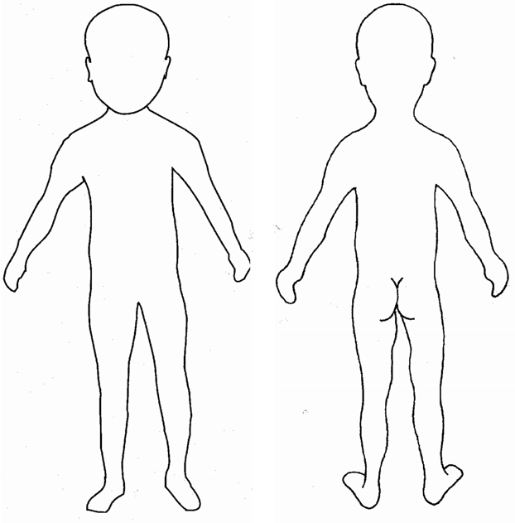
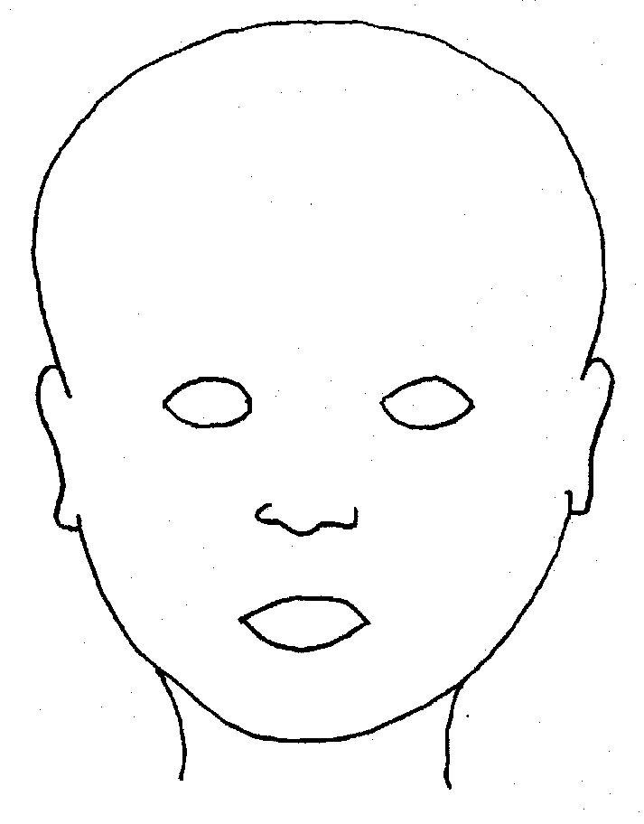

FRONT BACK
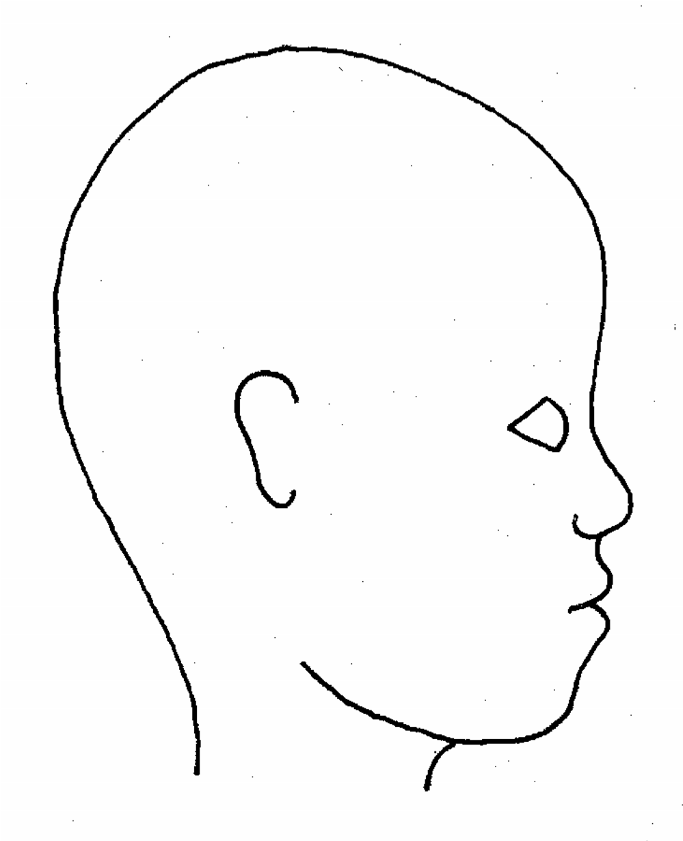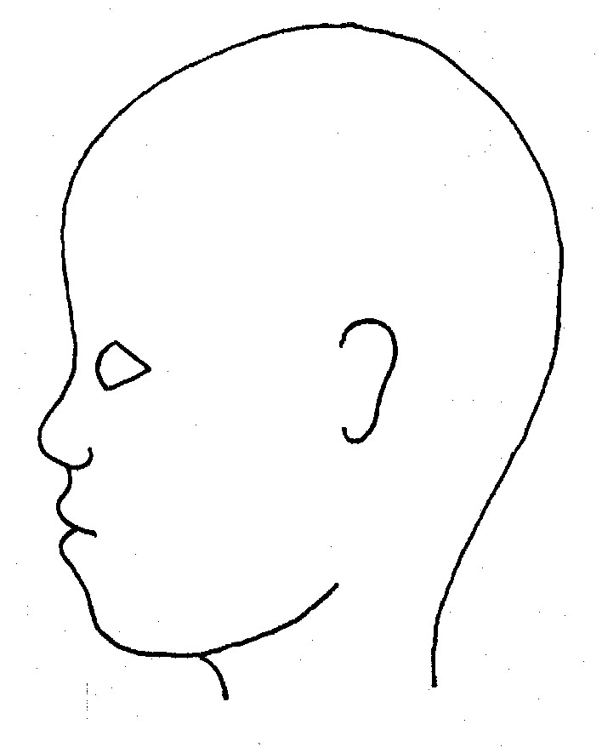

RIGHT LEFT

Name of individual:_______________________ | Date and time of observation:______________

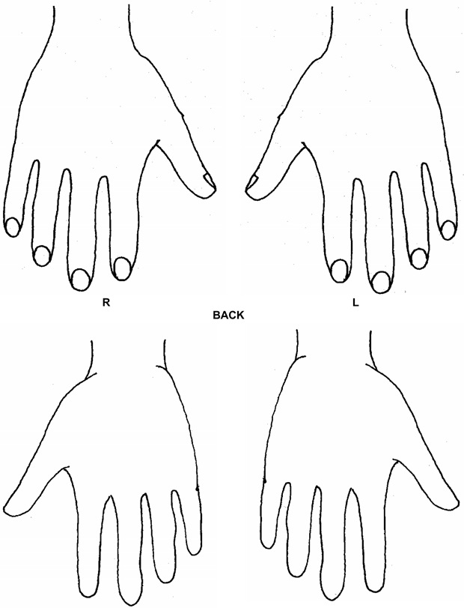

Name of individual:_______________________ | Date and time of observation:______________

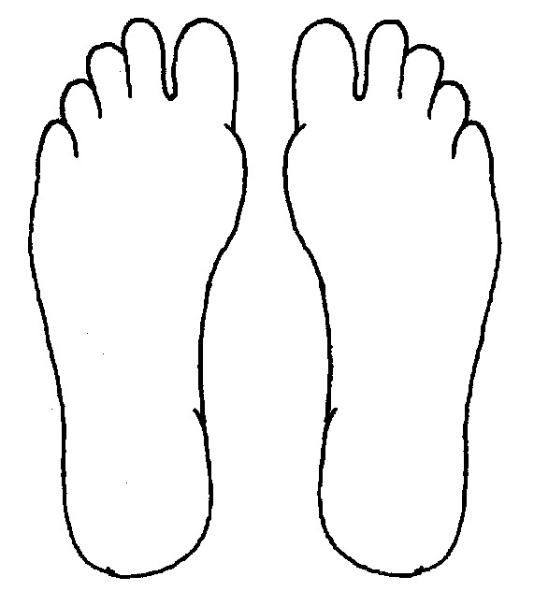
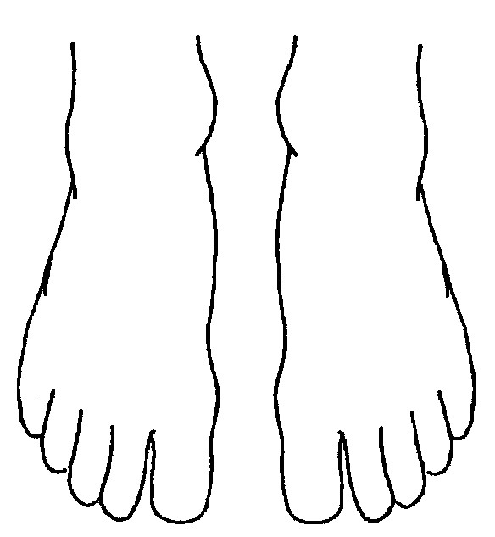
R BOTTOM L
R TOP L

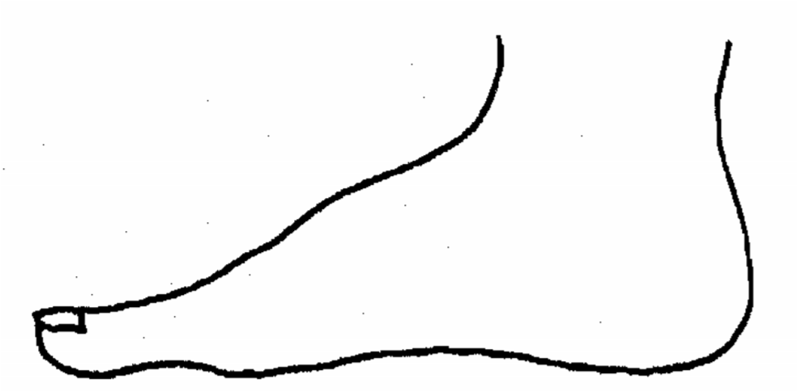
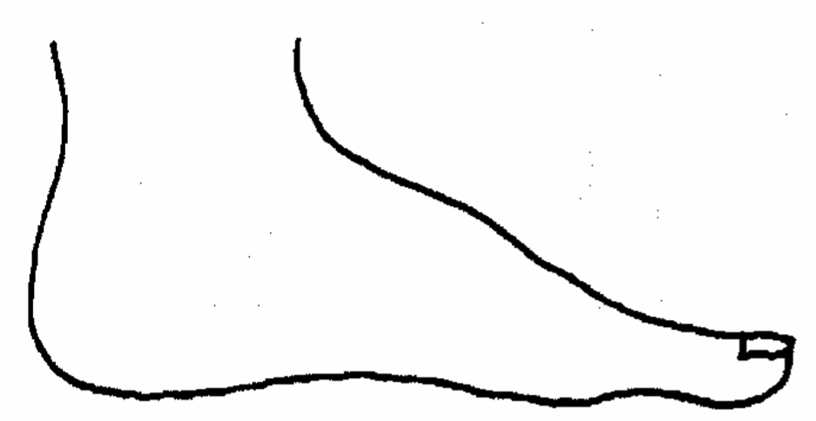

R INNER L

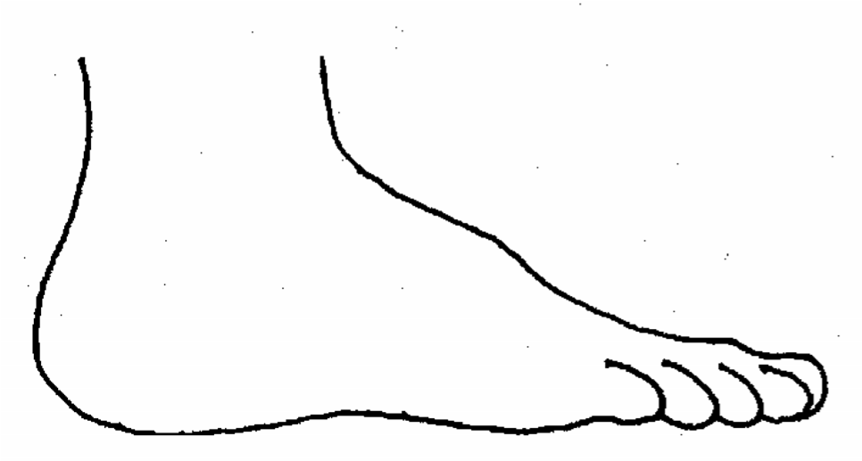
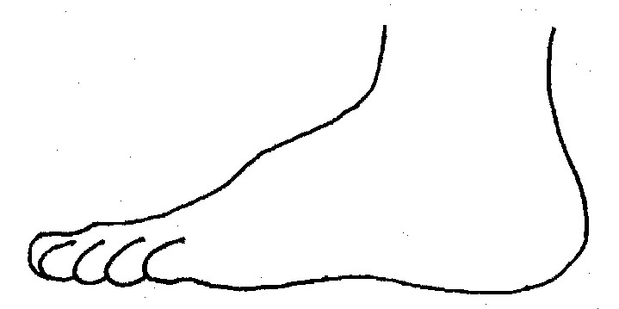
R OUTER L

Name of individual:_______________________ | Date and time of observation:______________
Printed name, signature and job title of staff:___________________________________________

Consent Form for Use of Images of Children or Vulnerable Adults

I………………………………………………………..myself or the parent/guardian/carer of:

(full name)……………………………………………………………………..

(full name)……………………………………………………………………..

(full name)……………………………………………………………………..

hereby give Earth in Common permission to use any still and/or moving image being video footage, photographs and/or frames and/or audio footage depicting the children or vulnerable adults named above,
taken by (name of photographer) …………………………………………………..

on behalf of Earth in Common, on (date)………………………………………

at (place)……………………………………………………………………………… for any of the following uses:

• Advertisements, marketing, leaflets, or any other use, such as for training, educational or publicity purposes.

The above consents will apply throughout the world and be for an indefinite period/expire on

(date).…………………………………….(delete as appropriate)

Signed………………………………………....Date…………………………………

Signed………………………………………....Date…………………………………

Address………………………………………………………………………………

………………………………………………………………………………………...

Postcode………………………………..

National Guidance for Child Protection in Scotland. www.scotland.gov.uk/Publications/2010/05/27095252/2

